1.5 – Solving Inequalities

Linear Inequality: linear equation with inequality symbol
(<, >, ≥, ≤) instead of the equals sign (=)

Compound Inequality: two simple inequalities joined by “and” or “or” (-2 ≤ x < 1, x < 1 or x ≥ 2)

Solution to an Inequality: value of the variable that makes the inequality true

Examples
Decide whether the given number is a solution of the inequality
10 – x 3 when x = 7 –8 < x – 11 < -6 when x = 5

Solving Linear Inequalities:
- Use Addition, Subtraction, Division, and Multiplication properties of equality (same as with an equation)

Reverse the Inequality
- If you have to Multiply or Divide both sides by the same negative number, then you must reverse the inequality

Examples
Solve the Inequality
4x + 5 > 25 5 – 2x ≤ 27

-8 < 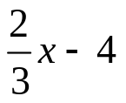< 10 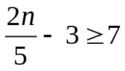or 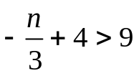

Graphing an Inequality: all the points on the real number line that correspond to solutions of the inequality.
- Open circle if < or >
- Closed circle if ≤ or ≥
- Shade region that applies

Graph the following:
x < 4 x ≥ -2

-4 < x < 6 x > 4 or x ≤ -4

Quick Quiz:
Solve:
7 – n 19 x + 2 5 or x – 4 2

Graph:
x < -2 or x > 3 1 ≤ x ≤ 7

HMWK: pg 37-38 #3-5, 15-19(odd), 27, 37-39 (odd)

